[IBM®](http://www.ibm.com/us/)

**IBM Corporation**

**STATEMENT OF WORK**

**Project Comet**

Py-R-K8s Project for Financial Services

PREPARED ON:

July 25, 2019

TABLE OF CONTENTS

1.0 Introduction 3

2.0 Mission Statement 3

3.0 [CUSTOMER OR PROJECT NAME] business objectives And Technical Challenges 3

4.0 [CUSTOMER OR PROJECT NAME] business requirements 3

5.0 Project Plan 3

6.0 Proposed Tests and Critical Success Criteria 4

7.0 PROJECT ASSUMPTIONS 4

7.1 Human Resource Assumptions 4

7.2 Technical and facilities Assumptions 4

7.3 PYRK8S PROJECT location 6

7.4 Pre-Installation Meeting (If Applicable) 6

7.5 Roles and Responsibilities 7

8.0 Technical milestones 8

9.0 Approval 9

APPENDIX A – NON DISCLOSURE AGREEMENT 10

APPENDIX B – Test Specifics / Customer Environment 11

B.1 IBM Software Products 11

B.2 Metadata Repository Database 11

B.3 Data & Application Connections 11

B.4 Network Topology 11

B.5 Preparatory Questions 12

# 1.0 Introduction

This PyRK8s project describes the business services provided by IBM Corporation (“IBM”) to key **Financial Service Sect**or Clients utilizing the **Project Comet** business solution.

# 2.0 Mission Statement

This document is intended to outline the processes in which IBM will work with key **Financial Services Sector Clients** on the evaluation and adoption of the **Project Comet** business platform solution.

This document provides an evaluation project plan along with associated success criteria.

# 3.0 Project Comet: business objectives & Goals

This section provides a high-level overview of the typical business objectives and business goals an FSS Clients might target with the improvement of their auto insurance bid/quote processes and subsequent underwriting processes.

**Auto Insurance Digital Strategy:**

A platform that delivers a personalized, empowering and seamless experience for requesting auto insurance quotes, eligibility determination and policy underwriting.

It is expected that these new business model capabilities will revolutionize the consumer experience for buying auto insurance and will deliver increased efficiency, adaptability and sustainability via a modern digital platform.

# 4.0 Project Comet: business requirements

**Client Engagement and Communication Focused:**

* Provide a platform for connecting key stakeholders who participate in the auto insurable buying process in real-time (consumers, agents and underwriters).
* Provide a platform that delivers smart and geographically aware mobile devices capabilities.
* Provide a platform that can consume, in near real-time, weather related data impacting the auto insurance processing flows.
* Provide a platform that is ubiquitous and delivers a multi-channel delivery experience.

**Key Business Drivers:**

* **Improved Time to Market:** Embrace the adoption of agile and continuous delivery models to break down silos between clients, agents, underwriters and supporting systems & services.
* **Digital:** Delivery of an omni-channel digital experience that is seamlessly accessible between mobile, web and internet of things (voice) channels.
* **Affordability:** Reduce operational costs and increase efficiencies via a revolutionary system of engagement delivery model and platform.

# 5.0 Project Comet: Proposed Architecture

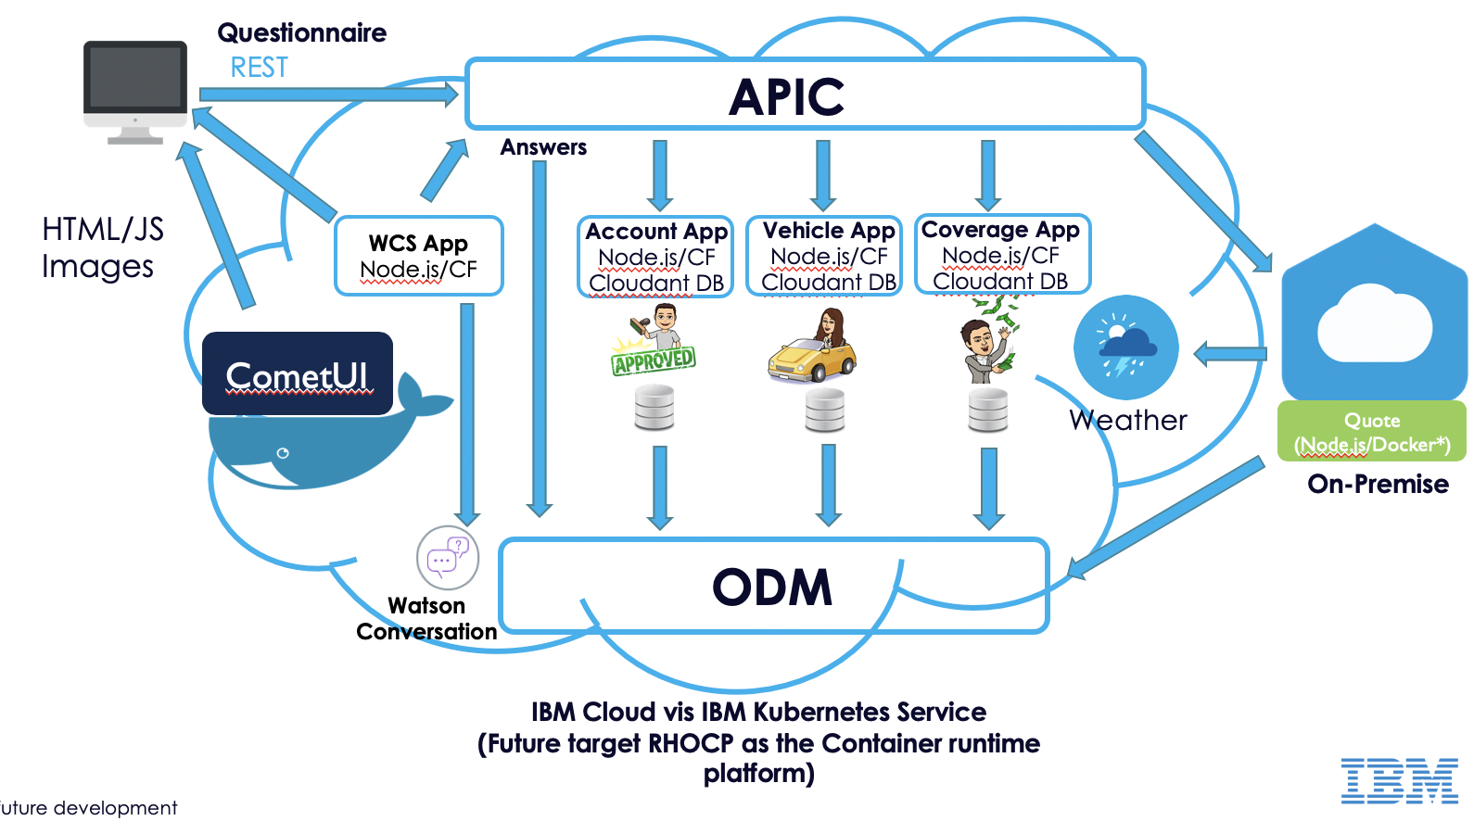

# 6.0 Project Comet: Project Plan

|  |  |  |  |
| --- | --- | --- | --- |
| **Event** | **Week of** | **Responsibility** | **Status** |
| Technical meeting | 7/24/2019 | Both | Complete |
| High level Client meeting to confirm alignment. | [date] | Both |  |
| Client discussions regarding scope | [date] | Both |  |
| Confirm agreement on defined project success criteria. | [date] | Both |  |
| Confirm project engagement sign-off | [date] | Both |  |
| Targeted project start date | 7/25/2019 | Both | Started |
| PYRK8S PROJECT targeted completion date | [date] | Both |  |
| PYRK8S PROJECT results presentation | [date] | Both |  |

* The above project plan represents a mutually agreed upon timeline to ensure resources and expectations are properly aligned between IBM and the PyRK8s Review Board during this PyRK8s exercise.

# 6.0 Proposed Tests and Critical Success Criteria

It should be understood that the PyRK8s process is intended to demonstrate core competency to resolve the business objectives relative to the Customer or Project’s identified business requirements. As a limited engagement, expectations should be set such that all parties understand that the PyRK8s project is not a full solution deployment.

The goal of the following tests is to confirm that the proposed solution: [products] addresses and solves the business requirements of Customer or prescribed project as noted in Section 4.

The customer or PyRK8s Project Review Board has identified and agreed that the following tests are to be used as success criteria in order to meet that goal.

The customer or PyRK8s Project Review Board has also identified and agreed that the following tests are out of scope for this PYRK8S PROJECT.

NOTE: No IBM software may be installed in a production environment, nor may any IBM personnel work on, connect to, or otherwise affect any production systems, networks or databases.

NOTE: If applicable, for specific testing environment details, additional scenario details, and additional notes please refer to Appendix ‘B’ Test Specifics/Customer Environment. A checkmark indicates that each specific test has been verified by the customer as completed successfully.

1. Install products on [system and environment description].
2. [summary description of test scenario 1]. (All test requirements should be tied to directly one or more business requirements from 4.0)

# 7.0 PROJECT ASSUMPTIONS

## 7.1 Human Resource Assumptions

IBM will provide a product specialist for the duration of the setup and testing.

If applicable, the customer will provide System Administrators, Database Administrators and other team members as needed by IBM for the installation, configuration, system and data access, and completion of all required tests.

## 7.2 Technical and facilities Assumptions

* IBM will provide the necessary product, product documentation and temporary license keys (for the duration of the PYRK8S PROJECT).
* If applicable, the CUSTOMER will:
* provide onsite/remote access and technical support to the operating systems, databases and any applications being used for the duration of the test(s);
* provide all hardware, operating systems, databases, and software (exclusive of IBM software to be tested) that is required to conduct the tests;
* provide detailed system configuration information for all systems on which IBM software is to be installed including operating system versions, patch levels, database versions and patch levels, and a listing of all additional applications installed;
* provide system accounts and sufficient access rights on all systems and databases to be tested as needed to complete the tests (typically root access);
* share any testing plans (automated and manual) with the IBM Systems Engineer onsite or remote;
* share their testing results with the IBM Systems Engineer on site;
* ensure that the agreed operating systems and databases will be installed on the test servers before testing begins.
* provide remote internet access to the test system(s) in the event remote support is required;
* provide a working area with adequate office supplies, etc.
* participate in a daily progress call, or meeting, between the IBM team, the [CUSTOMER OR PROJECT NAME] team and the senior [CUSTOMER OR PROJECT NAME] person responsible for the software purchase decision.
* IBM will:
* Establish PyRK8s team for the disciplines of Data Science (Python or R) or Application Modernization (Kubernetes)
* If applicable, working with the Customer, the IBM team will develop a schedule for executing the proof.
* The IBM team will assist in designing and executing the prospects test scenarios.
* If applicable, conduct daily status meetings with customer.
* If applicable, customer Support will maintain a log of all problems or incidents reported and provide on-going updates as required.
* IBM and the CUSTOMER will:
* IBM team working jointly with the customer project team, if applicable, will implement a prototype system as the requisite functional PyRK8s.
* If applicable, the Customer will notify the IBM team to monitor any problems or incidents that occur during the testing.
* If applicable, IBM will use established procedures to receive, track and resolve problems or incidents reported by the site.
* A daily status meeting will review the progress and remaining tasks.
* The proof will be declared completed upon a verbal agreement between the PyRK8s Review Board, which can include customer(s) and the PyRK8s project team.

## 7.3 PYRK8S PROJECT location

[CUSTOMER OR PROJECT NAME]

[customer address]

[near by lodging options]

## 7.4 Pre-Installation Meeting (If Applicable)

The purpose of the meeting is to fully qualify the client’s technical environment for the proof and discuss the installation process. This is typically scheduled as this document is presented. There are four main objectives for this meeting:

1. Define the functionality that makes up the PyRK8s.
2. Identify specific tasks necessary to implement the identified prototype, identify IBM’s consulting, involvement, discuss training requirements, assign client and IBM Software’s responsibilities, create project plan.
3. Prepare the environment by providing the required facilities/equipment and ensure all prerequisite software/hardware is available.
4. Schedule the proof.
5. Sign-off on test requirements and objectives as defined in this meeting.
6. Identify a focal point and primary liaison for the IBM team.
7. Initiate IBM resources access to test environment.
8. Identify staff resources for the PyRK8s’s duration.

## 7.5 Roles and Responsibilities

|  |  |  |
| --- | --- | --- |
| **ROLE** | **RESPONSIBILITIES** | **PERSON** |
| **PYRK8s Required** | | |
| PyRK8s Review Board Signing Authority | Acceptance of global scope of PYRK8S PROJECT and project plan. | [Lise PyRK8s Review Board members’ contact names & contact info] |
| Customer Signing Authority, if applicable | Acceptance of global scope of PYRK8S PROJECT and project plan. | [customer contact name & contact info, if applicable] |
| Product Specialist  (IBM) | Technical contacts, providing onsite technical support for Customer PYRK8S PROJECT. Verifies evaluation plans, test plans, provides technical knowledge transfers. Installs and configures products, assists in physical testing. | [IBM Technical Specialist(s) & contact info] |
| SCA  (IBM) | Architect contact, providing onsite architecture support for Customer or PYRK8S PROJECT. Verifies project scope, project architecture and design. | [IBM Architect(s) & contact info] |
| Support Specialist, if applicable | Technical support contact to assist IBM product specialists with product support requirements | [IBM support & contact info, if applicable] |
| **OTHERS AS APPLICABLE** | | |
| Project Manager  (Customer) | Provide Customer physical and technical resources to complete objectives of PYRK8S PROJECT. Facilitates scheduling of technical resources, timeframes, PYRK8S PROJECT technical goals and objection handling. | [customer contact name & contact info] |
| Systems Administrator (Customer) | Provide Customer physical and technical resources to complete objectives of PYRK8S PROJECT. May be more than one person. | [customer contact name & contact info] |
| Database Administrator  (Customer) | Provide Customer physical and technical resources to complete objectives of PYRK8S PROJECT.  Installation, Configuration & Monitoring - Knowledge Transfer Contact. May be more than one person. | [customer contact name & contact info] |
| Project Coordinator  (IBM) | Identification of customer requirements, primary customer contact. | [IBM sales representative & contact info] |
| Technical Project Manager  (IBM) | Provide IBM technical resources to complete objectives of PYRK8S PROJECT. Facilitates scheduling of technical resources, timeframes, | [IBM lead ITS & contact info] |

# 

# 8.0 Technical milestones

| **MILESTONE** | **DATE** |
| --- | --- |
| PYRK8S PROJECT Commencement and Kick-Off | [date]: 1 hour |
| Technical Environment Review | [date]: 2 hours |
| Product Installation, if applicable   * Install Product on server(s) * Install Client * Verify installation * Configure Sample Test * Verify Connectivity | [date] through [date] |
| Configure and Start Tests | [date] |
| Complete Tests | [date] |
| PYRK8S PROJECT Wrap Up | [date] |
| Agree that IBM can provide the technical solution to solve the business problem. | [date] |

# 9.0 Approval

The signatures below confirm that the PYRK8S PROJECT business requirements and testing objectives covered within this document are acceptable to both parties. The signing authority for Customer acknowledges that pending successful completion of this Proof of Value Pilot, IBM Corporation and Customer will work in good faith towards the completion of a commercial business transaction.

|  |  |
| --- | --- |
| **IBM CORPORATION**  **By:**  **Name:** [IBM PyRK8s Review Board Member]  **Date:** [date] | **CUSTOMER, if applicable**  **By:**  **Name:** [customer contact name]  **Title:** [title]  **Date:** [date] |

# 

# APPENDIX A – NON DISCLOSURE AGREEMENT

**If applicable, is NDA on file?**

# APPENDIX B – Test Specifics / Customer Environment

Detailed information on major systems components involved in the Customized demo/PYRK8S PROJECT including: Servers, Client Machines, Network, Databases, Specific Test Scenarios

# B.1 IBM Software Products

|  |  |  |  |  |  |
| --- | --- | --- | --- | --- | --- |
| **✓** | **IBM Product / Technology** | **Platform** | **Bits** | **Version** | **Patch Level** |
|  |  |  |  |  |  |

# B.2 Metadata Repository Database

|  |  |  |  |  |
| --- | --- | --- | --- | --- |
| **Repository Database Brand** | **Platform** | **Bits** | **Version** | **Patch Level** |
|  |  |  |  |  |

# B.3 Data & Application Connections

|  |  |  |  |
| --- | --- | --- | --- |
| **Database Brand** | **Platform** | **Bits** | **Version** |
|  |  |  |  |

# B.4 Network Topology

[insert simple network drawing here that includes systems, SAN’s, and firewalls between and used by all client and server systems]

# B.5 Preparatory Questions

| **Question** | **Answer** |
| --- | --- |
| Any unusual security requirements for system access? (fingerprinting, etc) |  |
| Has appropriate software and/or reference data been ordered? |  |
| What type of group workspace is available for the project team? Project room is preferred. |  |
| Occasional use of a whiteboard will be required during the week. Will one be available? |  |
| Are there any issues regarding IBM IT Specialists accessing corporate data, if applicable? |  |
| Do you have access to the Internet for e-mails and file transfers? |  |
| What needs to be arranged for building security? Are background checks required? What lead times are required? |  |
| What needs to be arranged for building security with regards to the entry and exit of PC’s, CD/DVD’s, memory devices? |  |
| What is the dress code at the location where the IBM IT Specialists will be working? |  |
| What are normal working hours? Is special permission required to arrive early or leave late? Is the team prepared to adjust working hours? |  |
| Will projection capabilities be provided for final presentation of results? |  |
| Will the system admin, if applicable, be available on the first day of the PYRK8S PROJECT to assist with the installation? |  |
| Will the IBM IT Specialist have administrative rights to the client PC, if applicable? |  |